E-Commerce Customer Churn Prediction
Final Week — Data Science Insights, Communication & Recommendations
Professional Data Science Report & Presentation Plan

1. Executive Summary
This report presents a polished communication and decision-making plan for a hypothetical E-Commerce Customer Churn Prediction project. The purpose of the project is to identify customers who are at risk of becoming inactive and translate analytical results into practical business actions. The analysis is designed around customer purchasing behaviour, including order frequency, spending, time since the last purchase, returns, reviews, and related engagement indicators.
The hypothetical analysis suggests that customer recency is one of the strongest warning signals. Customers who have not purchased for a long period are expected to have a substantially higher likelihood of churn than recently active customers. Lower order frequency and weaker spending behaviour can provide additional evidence of declining engagement, while repeated returns may indicate dissatisfaction or a poor experience. These findings should be treated as planning assumptions rather than measured results because the project is being developed as a hypothetical case without a real production dataset.
The key business message is simple: instead of treating all customers equally, the company can prioritize customers according to their estimated churn risk. High-risk customers can receive timely and relevant re-engagement actions, while lower-risk customers can continue through normal loyalty and retention programs. The proposed communication approach avoids technical jargon and focuses on what changed, why it matters, what action is recommended, and how success should be measured.
The report also proposes mock visualizations, an executive storytelling structure, an action-priority framework, and a plan for future work. Together, these elements show how a data science project can move from analytical findings to understandable recommendations and measurable business decisions.

2. Methodology Overview
The project follows a standard end-to-end data science approach while keeping the final communication focused on business value. First, the business problem is translated into a measurable churn prediction objective. Relevant customer-level variables are identified, and data quality checks are planned before analysis.
Data preparation includes checking data types, missing values, duplicate records, inconsistent categories, impossible values, and extreme observations. Features such as days since last purchase, total orders, spending, return behaviour, and customer engagement are prepared in a consistent format. Exploratory analysis is then used to understand distributions, relationships, segment differences, and unusual patterns.
For the predictive stage, classification models such as Logistic Regression, Decision Tree, and Random Forest can be compared. A training and testing strategy with cross-validation is planned so that the final assessment is less dependent on a single data split. For a churn problem, recall and F1-score are especially useful because missing a genuinely at-risk customer may be costly. Precision and ROC-AUC provide additional views of model quality.
The final stage converts model output into business segments such as low, medium, and high risk. Instead of presenting model coefficients or technical details as the main message, the communication layer focuses on customer behaviour, risk signals, recommended interventions, expected business value, and measurable follow-up metrics.

3. Insights and Analysis

3.1 Customer Activity and Churn Risk
The most important hypothetical insight is that recency of customer activity should be closely associated with churn risk. A customer who has gone many days without purchasing may represent a declining relationship with the business. This creates an opportunity for earlier intervention rather than waiting until the customer becomes completely inactive.
A second expected pattern is that customers with fewer orders may be more vulnerable to churn because they have a weaker purchasing relationship with the business. Spending can add another layer of information: high-value customers who become inactive may deserve priority because the potential revenue at risk is greater.
Returns provide a possible experience-related warning signal. A high return frequency does not automatically mean a customer will churn, but it can indicate friction in product quality, expectations, delivery, or service. Review activity can also provide useful context, particularly when combined with other engagement indicators.

3.2 Mock Analytical Findings
The following visuals are intentionally labelled as mock visualizations. Their purpose is to demonstrate how results could be communicated after real analysis. They should not be interpreted as actual measured business performance.
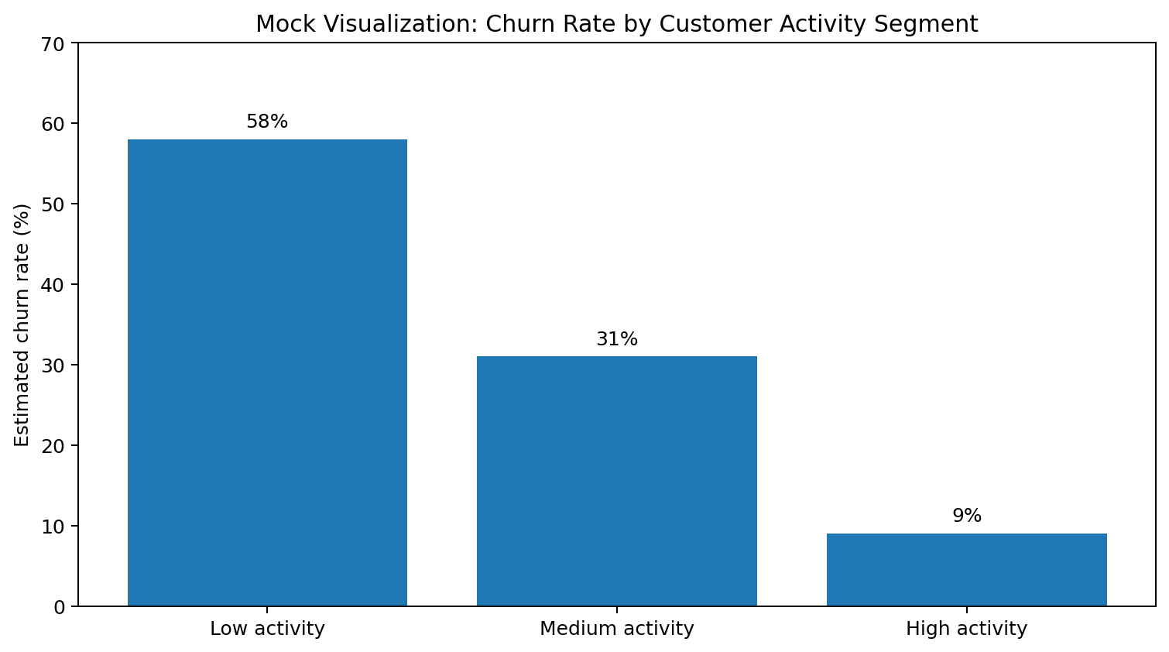
Figure 1. Mock segmentation view showing how activity level could be communicated to decision-makers.
Figure 1 uses a simple segment comparison because executives can understand percentages quickly. If real data confirmed a similar pattern, the business could focus retention resources on low-activity customers while maintaining appropriate engagement for other groups.
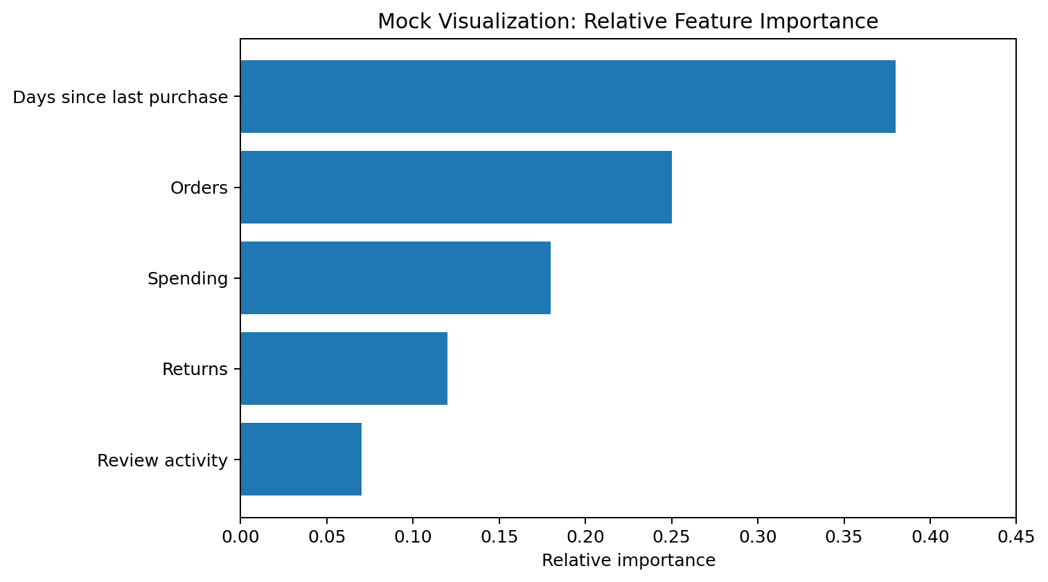
Figure 2. Mock feature-importance view illustrating how model drivers could be summarized without exposing technical complexity.
Figure 2 is useful because it answers a practical question: which customer behaviours deserve attention? A model explanation should be presented as an aid to decision-making rather than proof of causation. For example, if days since last purchase is highly influential, the business can investigate timely re-engagement strategies.

3.3 Recommended Supporting Tables
Risk group | Typical signal | Business response | Success measure
High | Long inactivity + weak engagement | Targeted re-engagement | Reactivation rate
Medium | Declining activity | Personalized offer/content | Repeat purchase rate
Low | Recent and consistent activity | Loyalty/normal communication | Retention and CLV

4. Visualization and Narrative Strategy
Each visualization should answer one business question. The report should avoid filling pages with charts that do not change a decision. Trends can be shown using line charts, distributions with histograms or box plots, relationships with scatter plots, category comparisons with bar charts, and correlations with heat maps. Model performance can be communicated through a compact metric table and, where appropriate, an ROC curve or confusion matrix.
The recommended order is: establish the business problem, show the size or profile of the customer-risk issue, explain the main behavioural signals, present the model's predictive performance, and then move directly to actions. This creates a logical story instead of a collection of unrelated technical outputs.

5. Presentation Strategy for a Non-Technical Audience
The presentation should be designed for a manager or business stakeholder who may not understand machine learning terminology. The central story should be structured around four questions: What is happening? Why does it matter? What should we do? How will we know whether it worked?
Technical terms should be translated into business language. For example, instead of saying 'the classifier has high recall,' the presentation can explain that 'the model is designed to identify a large proportion of customers who are genuinely at risk.' Instead of focusing on algorithm names, the presenter should explain that several approaches were compared and the selected approach provided an appropriate balance between identifying risk and avoiding unnecessary interventions.
Every slide or report page should have a clear takeaway. Visuals should have descriptive titles, labelled axes, readable units, and short explanations. Avoid unnecessary 3D charts, excessive colours, and dense tables. When uncertainty exists, it should be stated openly. Hypothetical findings should never be presented as verified business facts.

6. Actionable Recommendations
- Prioritize high-risk customers for timely re-engagement campaigns based on recent inactivity and declining purchasing behaviour.
- Create customer segments so retention actions can be personalized instead of sending the same message to every customer.
- Investigate repeated returns as a possible customer-experience signal and connect return patterns with product, delivery, and service information.
- Track reactivation, repeat purchase, revenue retained, and campaign cost to determine whether interventions create measurable value.
- Use model explanations to help business teams understand why a customer is classified as high risk and to support responsible decision-making.
- Review model performance regularly after deployment and retrain when customer behaviour, products, or market conditions change.
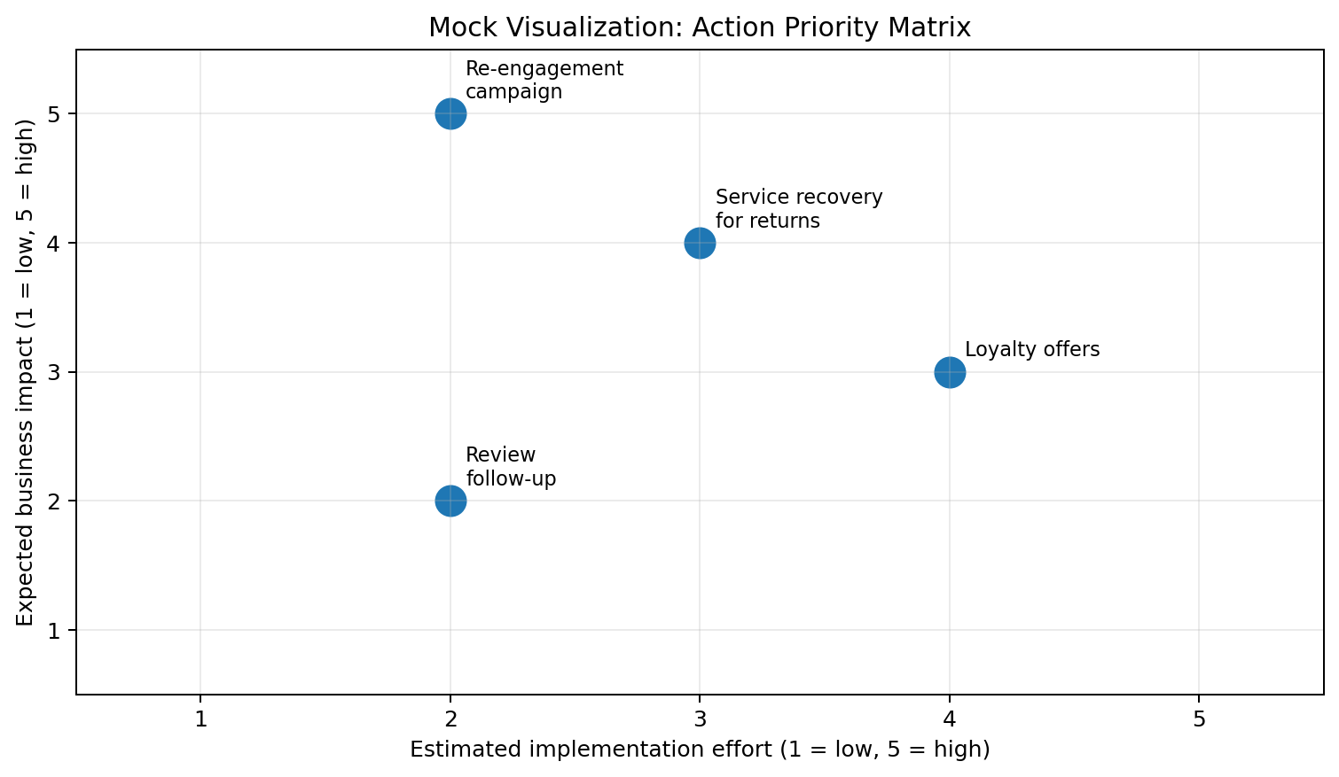
Figure 3. Mock action-priority matrix for communicating which interventions should be considered first.

7. Future Work
Future work should move from the hypothetical planning stage to a real implementation using an appropriate anonymized customer dataset. The first priority would be to verify whether the proposed behavioural relationships actually exist. Once verified, the project can include reproducible Python notebooks, automated preprocessing, model training, experiment tracking, and a final model evaluation.
Additional work could include customer lifetime value analysis, time-based validation, calibrated churn probabilities, cost-sensitive classification, and controlled A/B testing of retention campaigns. A production system could expose risk scores through a secure application or scheduled business dashboard. Monitoring should cover prediction quality, data drift, changes in customer behaviour, and business outcomes. Privacy, access control, and responsible use of customer information should remain part of the implementation plan.

8. Risks and Mitigation
Potential challenge | Risk | Mitigation
Data quality issues | Unreliable insights | Validation rules, missing-value checks, duplicate checks
Class imbalance | Poor minority-class detection | Use recall/F1, stratification and suitable resampling
Overfitting | Weak performance on new data | Cross-validation, regularization and hold-out testing
Model drift | Performance declines over time | Monitor drift and retrain periodically
Poor communication | Insights are not acted upon | Use simple visuals, takeaways and action-oriented language

9. Proposed Executive Presentation Structure
- Opening: State the customer-retention problem and why it matters.
- Business context: Explain what customer churn means in practical terms.
- Data and approach: Give a short explanation of the information and analytical process.
- Key findings: Present only the most decision-relevant patterns.
- Risk view: Show how customers could be grouped by predicted risk.
- Recommendations: Connect each important finding to a specific action.
- Measurement: Define KPIs for judging whether the actions worked.
- Next steps: Explain implementation, monitoring, and further analysis.

10. 30–35 Hour Work Plan
Activity | Hours | Output
Review project objective and define communication goals | 3 | Executive narrative
Prepare methodology and analytical story | 5 | Methodology summary
Develop hypothetical findings and business interpretations | 6 | Insight statements
Design mock charts, tables and visual hierarchy | 7 | Visual aids
Develop stakeholder presentation strategy | 4 | Presentation structure
Write recommendations, risks and future work | 4 | Action plan
Proofread, format and perform final quality review | 4 | Polished DOC report
Total planned effort: 33 hours

11. Conclusion
A strong data science project is not complete when a model produces a prediction. Its value comes from turning reliable analysis into a decision that people can understand and act upon. This final report demonstrates that process by connecting a hypothetical churn analysis with clear visual communication, stakeholder storytelling, measurable recommendations, and a realistic future implementation path.
The proposed approach keeps the technical analysis rigorous while presenting the results in business-friendly language. It also makes an important distinction between hypothetical planning and verified findings. With a real dataset, the same framework can be extended into reproducible analysis, model validation, deployment, monitoring, and controlled measurement of business impact.

12. Final Deliverable Checklist
- Executive summary included.
- Methodology overview included without relying on previous-task references.
- Hypothetical findings and analytical interpretation included.
- Mock visualizations and supporting table included.
- Non-technical presentation strategy included.
- Actionable recommendations and future-work plan included.
- Risks and mitigation strategies included.
- 33-hour work plan included within the required 30–35 hour range.
- Report formatted as a professional Word document.

